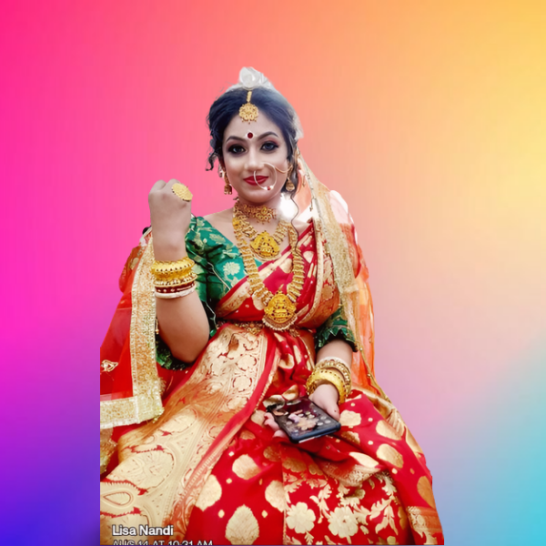 Lisa Nandi

Profesional Contect No-9500025823

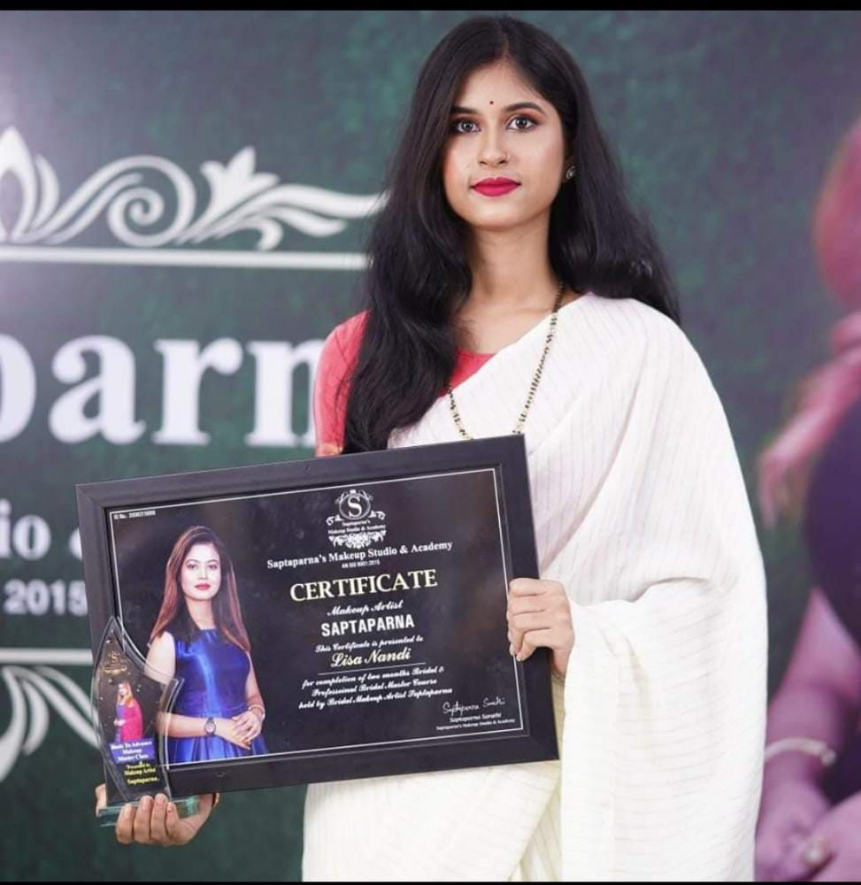 makeup

artist

*MAKE NAME*

1. Bridal Makeup

2. Reception Makeup

3.Non Bengali bridal Makeup

4. Party Makeup

5.Self Makeup

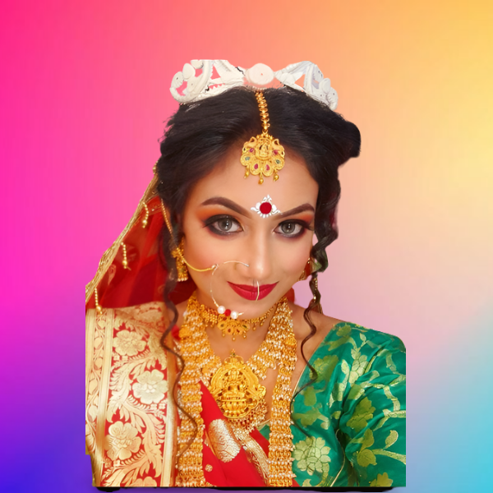6.Nude Makeup

7. Bold Makeup

8. Bronze Makeup

9. Night Makeup.etc

*All types of Eye Makeup*

*1.eyebrows drow*

*2.nude eye Makeup*

*3.spotlight eye Makeup*

*4.Cut crease eye Makeup*

*5.Glitter eye Makeup/glitter …etc*